Project1: The Stroop Task

### Q1: Independent variable & dependent variable

* **Independent variable:**

Color Congruency of word (including congruent words condition and incongruent words condition, which means whether the names of word match the colors they are printed)

* **Dependent variable:**

The time it takes for a participant to name the ink colors

### Q2: Hypothesis & statistical test

One-tailed t-test in negative direction

H0: μ1 ≥ μ2

Ha: μ1 < μ2

H0 – participant spends the same or more time to name the ink colors of congruent words than incongruent words

Ha – participant spends less time to name the ink colors of congruent words than incongruent words

μ1 – population mean time for participants to name a list of congruent words

μ2 – population mean time for participants to name a list of in congruent words

Assumptions

1. We assume population is approximately normally distributed
2. We assume the sample data can estimate population variance
3. Population variances are about equal

Since the paradigm of the Stroop task Repeated measure design, each participant will go through two different treatments, which, in this case, are incongruent words and congruent words. Therefore, the samples collected from this task are paired samples.

And because the population standard deviation σ is unknown, dependent t-test should be selected.

### Q3: Description of dataset

**Mean**

$\overline{x_{1}}$ = 14.05

$\overline{x_{2}}$ = 22.02

**Median**

Md1 = 14.36

Md2 = 21.02

**Sample standard deviation**

S1 = 3.56

S2 = 4.80

### Q4: Data visualization

The following box-and-whisker plot shows the data distribution of congruent and incongruent, which help us get insight into some very useful information. Here are some good examples for us understand this case better:

1. The median of incongruent group is higher than congruent group, which means the median time of name incongruent words is higher than that of congruent words.
2. The interquartile range(IQR) of congruent group is smaller than that of incongruent group.
3. And obviously, we can find some outliers in incongruent group and we definitely should get rid of them.

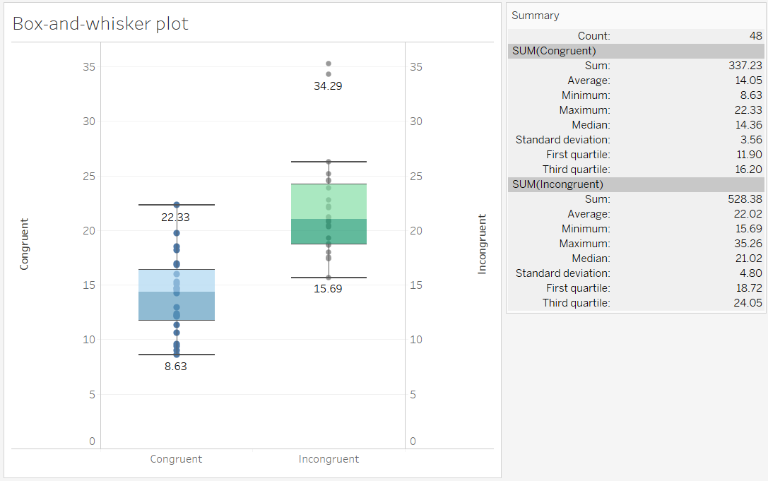

### Q5: Results

Descriptive statistic

Sample size:

n=24

Degree of Freedom:

df = 23

Mean:

$\overline{x_{1}}$ = 14.05

$\overline{x_{2}}$ = 22.02

Standard deviation:

SD = = 4.86

Inferential statistics

Test type:

paired sample test

t-statistic value:

tstatisitc = -8.021, p < .05 negative

t-critical value:

tcritical(23)= 2.069, p = .025 negative

Confidential interval(CI) on the mean difference:

95% CI = (-10.02, -5.92)

Under df = 23, the t-statistic value is far less than t-critical value, which means participants statistically significantly spend less time to name a congruent word than an incongruent word where p < .05, so we reject the null hypothesis.

Effect size measure

r2 = .74

The time of name the color of a word is 0.74 related to the difference whether it’s a congruent word or not.

Conclusion:

According to the results, participant spends less time to name the ink colors of congruent words than incongruent words, which matches up with our expectation.

### Q6

Reasons behind the test

Humans basically will visualize the word they memorized (Radvansky, Gibson & McNerney, 2011). In this case, each word represents a particular color, so when participants trying to speak out the word, they will try to link the word to a correct color in their memory. The right color tends to help participant retrieve the correct word of color in their memory quicker.

However, the wrong visualization of a word will interfere with retrieving it correctly. So when the mismatch between word and color occurs, the printed color of word will interfere brain with retrieving correct word to speak out.

That’s why the average responding time of first group is significantly shorter than that of first group.

Alternative tasks may have the similar effect

If we change the independent variable to shape congruency, we probably will get the similar result. We can redesign the task like this:

Independent variable: congruent shape or incongruent shape.

Dependent variable: the time to name the correct shape.

In this task, participant needs to say out the correct shapes of each group(see example)

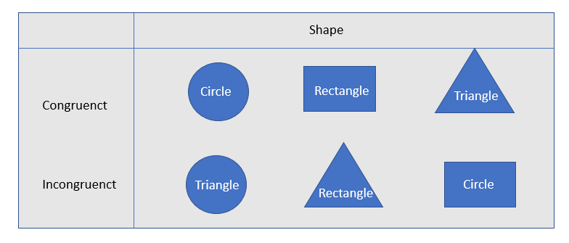

We expect that mean time of finish first group will shorter than the second group.

### Reference

Radvansky, G. A., Gibson, B. S., & McNerney, M. (2011). Synesthesia and memory: color congruency, von Restorff, and false memory effects. *Journal of Experimental Psychology: Learning, Memory, and Cognition*, *37*(1), 219.